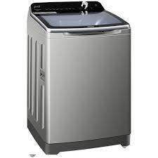

Fully-Automatic

* LED Display
* Capacity 16 Kg
* Child Safety Lock
* Type Top Load
* **Rs.98,500**